Plate Boundaries &
Geologic Formations
- What are the different ways plates interact?
  - ______________plate boundaries: 2 plates are moving away from one another due to rising convection currents
  - ______________plate boundary: 2 plates are moving towards each other due to sinking convection currents.
  - ______________plate boundary: 2 plates are sliding past one another

  - See ESRT page 12 – Global Tectonic Activity of the Last One Million Years.

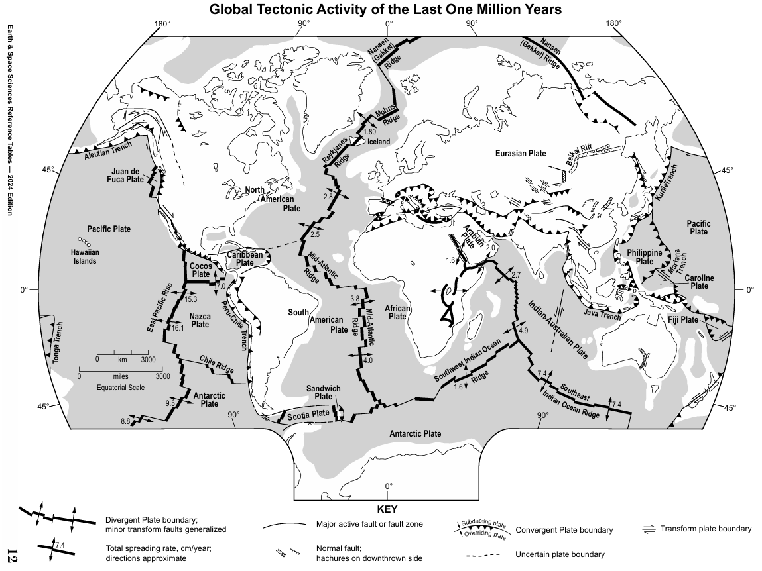
- What does the bottom of the Atlantic Ocean floor look like?

- Making Predictions: The cross section below shows the east coast of North America, the Atlantic Ocean, and the west coast of Europe. Using a pencil, draw what you think the ocean floor looks like as you travel from one continent to the other.
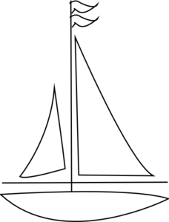



New York  New York | Rising magma | Europe

Asthenosphere

Explanation:
- In the middle of the Atlantic Ocean there is a _______________________. (See ESRT p5)
- At the plate boundary, there is a volcanic mountain range called a mid-ocean ridge.
- New seafloor forms here when magma solidifies and causes the seafloor to spread. This means North America and Europe are slowly moving away from each other.
- Checkpoint: Use ESRT page 5 to find another example of a mid-ocean ridge. What is the name of this ridge? What are the two plates that are diverging at this ridge?

- How do we know the seafloor is spreading at mid-ocean ridges?

Evidence of seafloor spreading:
- Age of bedrock:

  - ____________________________ . This is the _________crustal location due to rising magma.
  - Oldest bedrock is at either continent.

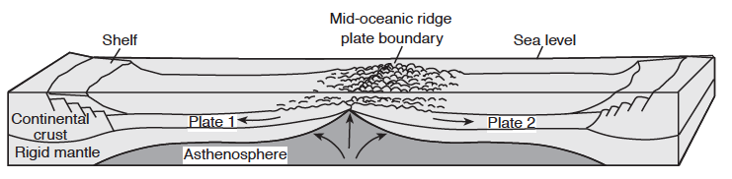
- ________________________ pattern of bedrock

  - Earth’s magnetic North Pole is currently near the geographic North Pole. In the past, it seems to have been reversed for periods of time, meaning the magnetic North Pole was located near the geographic South Pole.

  - As magma cools, magnetic elements like iron in the magma align to the Earth’s magnetic North Pole of the time.

  - Oceanic crust at equal distances on opposite sides of the ridge have the same magnetic polarity (normal + or reversed -). Meaning, the oceanic crust formed at the same time at the ridge and was pushed apart as new seafloor has been created.
  - Magnetic polarity pattern is a _________________ on opposite sides of the ridge.

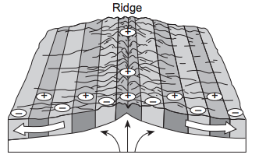
- What geologic features occur when a continental plate collides with an oceanic plate?
- Making predictions – Convergent Plate Boundaries: On the diagram below…
- Label each type of crust.
- Label the density of each type of crust.
- Using a pencil, draw what you think will happen when these two plates collide.



Volcanic Mountain Range


(Cascade Mountains in North America)

Oceanic Crust  3.0 g/cm³ | Pacific Ocean  X  X  X | North  America

Explanation:
- Continental-Oceanic Convergent Boundary: This is called a____________________ caused by the collision of an oceanic and continental plate

  - Because the oceanic crust is more dense, it will always subduct (move under) the less dense continental crust which destroys crust, causes deep earthquakes, forms ocean trenches, and forms continental volcanic mountains.

- Checkpoint – Continental-Oceanic Convergent Boundaries:

- Use ESRT page 5 to find the continental-oceanic plate boundary on the west coast of South America. Which two plates are converging at this boundary? What is the name of the trench formed at this boundary?

Base your answers to questions 2 through 5 on the map below which shows locations of the volcanic peaks of the Cascade Mountain Range of the northwestern United States. The table shows the major eruptions of each peak over the past 4,000 years.
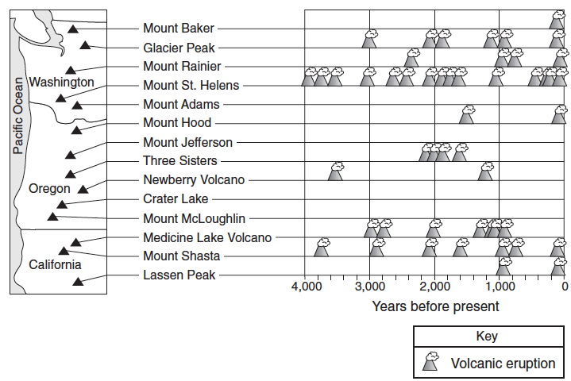


- Which volcano of the Cascade Mountain Range has erupted most frequently in the past 4,000 years?

- What type of plate boundary formed the Cascade volcanic mountains?

- What are the names of the two plates found on either side of this plate boundary?

- On the cross section below, place an arrow in the continental crust and an arrow in the oceanic crust to show the relative directions of plate movement.

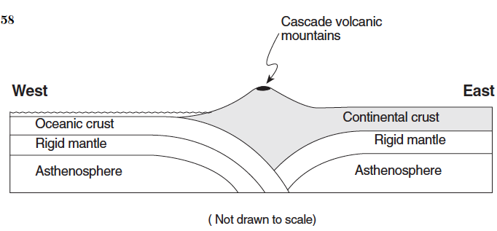
- What geologic features occur when two continental plates collide?
- Making Predictions – Convergent Plate Boundaries #2: The diagram below represents the bedrock of the India landmass moving towards the bedrock Eurasian Plate 10 million years ago.

India Land Mass Eurasian Plate
10 million years ago

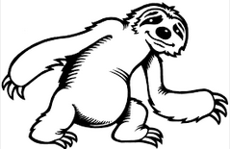

Using a pencil, draw what you think happened to the bedrock when these two plates collided to represent this area today.
Today
Folded mountain range

India Land Mass Eurasian Plate

Explanation:
- Continental-Continental Convergent Boundary: The collision of two continental plates forms ______________________, such as the Himalayan Mountains between the India land mass and the Eurasian Plate shown above.
- What geologic features occur when two oceanic plates collide?

- Making Predictions – Convergent Plate Boundaries #3: On the diagram below, use a pencil to draw what you think will happen when these two plates collide. The oceanic plate on the left is cooler and denser than the oceanic plate on the right.

Cooler &  Denser | Pacific Ocean  Ocean Trench

Explanation:
- Oceanic-Oceanic Convergent Boundary: The collision of two oceanic plates form _____ __________________________________________.

- Commonly known island arcs include the islands of Japan and the Aleutian Islands off the coast of Alaska.

- Checkpoint – Oceanic-Oceanic Convergent Boundaries: Use ESRT page 5 to find two ocean trenches formed by an oceanic-oceanic convergence.

- What geologic features form at a transform boundary?

- ______________________: one plate slides past another plate causing shallow earthquakes

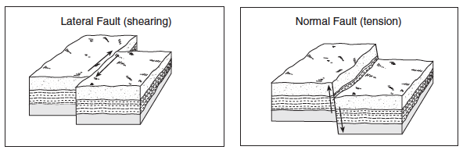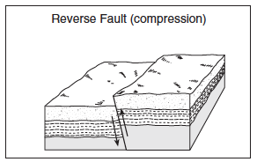

- Checkpoint – Transform Boundaries: Using ESRT page 5, find the transform boundary located in the continental United States. What is the name of this boundary? Which two plates are sliding past each other at this boundary?

- Checkpoint – Plate Boundaries: Use your knowledge of Earth Science and the Earth Science Reference Tables to answer the questions below.

- The movement of tectonic plates is inferred by many scientists to be driven by
a. tidal motions in the hydrosphere
b. density differences in the troposphere
c. convection currents in the asthenosphere
d. solidification in the lithosphere

- The diagram below shows some features of Earth’s crust and upper mantle.
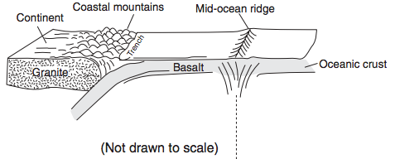
Which model most accurately shows the movements (arrows) associated with the surface features shown in the diagram?
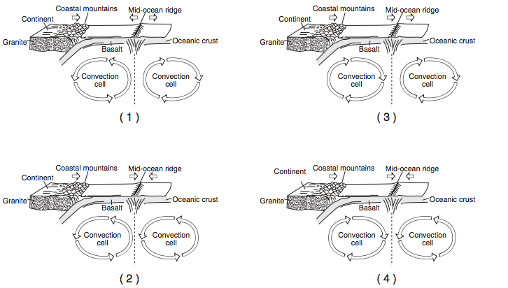
- According to tectonic plate maps, New York State is presently located
a. at a convergent plate boundary
b. above a mantle hot spot
c. above a mid-ocean ridge
d. near the center of a large plate

- Which coastal area is most likely to experience a severe earthquake?
a. east coast of North America
b. east coast of Australia
c. west coast of Africa
d. west coast of South America

- The map below shows the northern section of the boundary between the Arabian Plate and the African Plate. Arrows show the relative direction of plate motion.
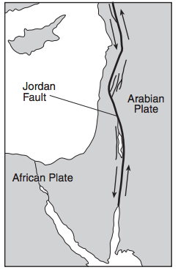
Which type of plate boundary is located at the Jordan Fault?
a. divergent c. transform
b. convergent d. complex

- Which of the following locations is the site of a convergent plate boundary?
a. the Mid-Atlantic ridge
b. the Aleutian trench
c. the Atlantic-Indian ridge
d. the Pacific/North American plate boundary

- Which tectonic feature is associated with a complex or uncertain plate boundary?
a. Southwest Indian Ridge c. Mariana Trench
b. East African Rift d. Galapagos Hot Spot

Base your answers to questions 8 and 9 on the block diagram below which shows the boundary between two tectonic plates.
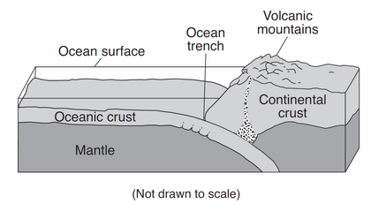
- Which type of plate boundary is shown?
a. divergent c. transform
b. convergent d. complex

- Which tectonic plate boundary is best represented by this diagram?
a. Nazca Plate and Pacific Plate boundary
b. Scotia Plate and South American Plate boundary
c. Juan de Fuca Plate and North American Plate boundary
d. Antarctic Plate and Indian-Australian Plate boundary
Base your answer to questions 10 through 12 on the cross section below, which shows the major surface features of Earth along 25° S latitude between 75° W and 15° E longitude. Points A, B, and C represent locations on Earths crust.

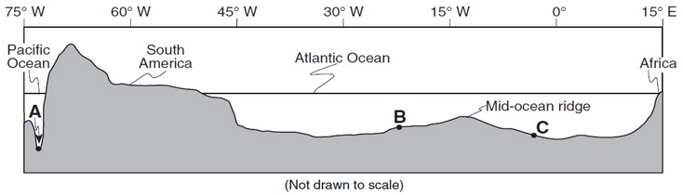

- Identify the crustal feature located at point A.

- Identify the tectonic plate motion that is causing an increase in the distance between South America and Africa.

- Bedrock samples were taken at the mid-ocean ridge and points B and C. On the grid, draw a line to show the relative age of the bedrock samples between these locations.

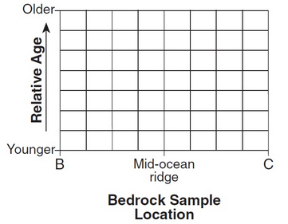

- The cross section below represents a pattern of magnetic field reversals preserved in the igneous bedrock of the oceanic crust east of the Mid-Atlantic ridge.
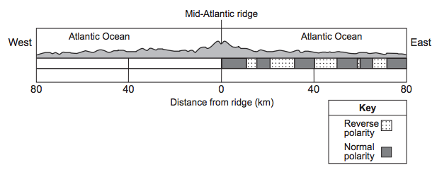
Complete the diagram above by shading the pattern of normal polarity on the west side of the ridge center. Assume the rate of plate movement was constant on both sides of the ridge center. Your answer must show the correct width and placement of each normal polarity section.

